**WALKING WATER**

**1 Sort out and colour.**

red green purple orange blue yellow

PRIMARY COLOURS SECONDARY COLOURS

(mixed together make other colours) (two primary colours mixed)

 

**2 What do we need for the experiment? Match.**

1 plastic towels

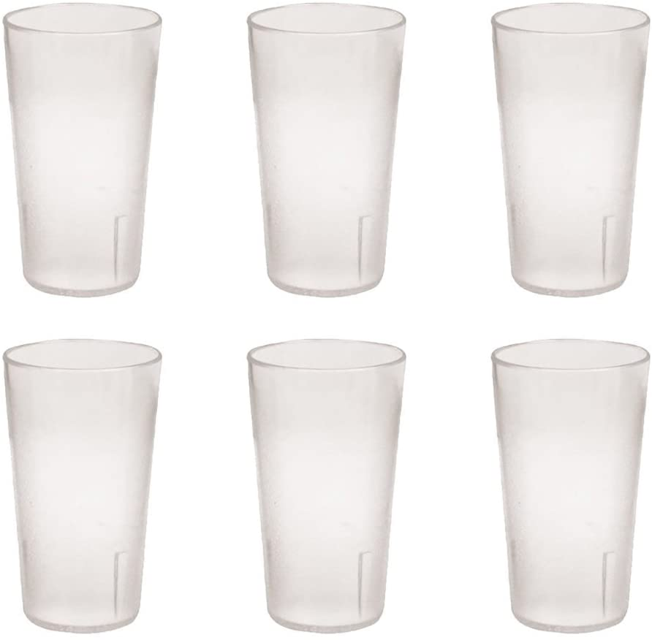



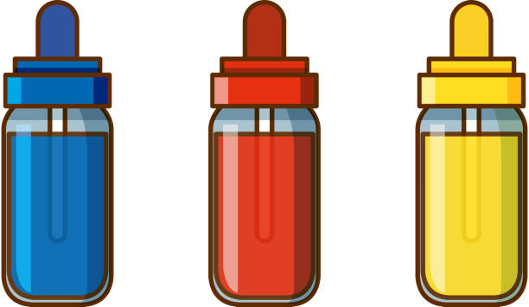

2 food cups

3 paper colouring

**___ ___ ___**

**3 Put in the correct order.**

 watch the water slowly go up the paper towels

fill 3 cups with water



 watch the secondary colours appear

 put an empty cup between each cup with coloured water

put one end of the paper towel in the coloured water and the other in



an empty cup

 put some food colouring (yellow, red and blue) into the 3 cups

 take six paper towels and fold them

**4 Illustrate what happens.**

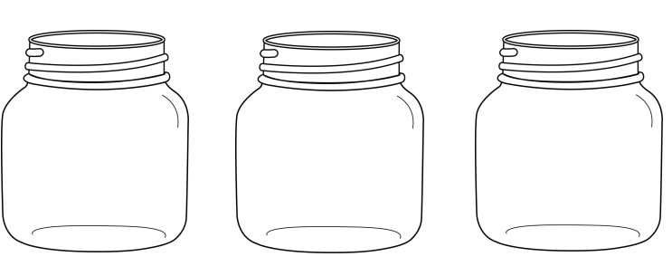



**5 Explain what happens.** Can water walk? How can you see? Which secondary colours can you see? How can you make them?

________________________________________________________________

________________________________________________________________

________________________________________________________________

________________________________________________________________

________________________________________________________________

________________________________________________________________

________________________________________________________________